Contents

Report(s) 1
Other Documents 1
Process steps 1
1. Preparation 1
2. Running the report 2
3. Clearing down by applicant status 2
4. Post clear down checks 5
5. Removing the merged PDF packs 5

Report(s)

RECSUP01 Applicant clear down control

Other Documents

Applicant clear down knowledge article – this should be read in conjunction with this ‘How To’ guide.

Bulk applicant clear down checklist

HOW TO - clear down applications at the request of an applicant

Process steps

Preparation

  - Create a new folder under P:\PROJECTS\HRIS Programme\12. Support\Applicant Clear down\Annual clear down and name it to show the year being cleared e.g 2010/11.

  - Open the bulk applicant clear down checklist and save a copy in the folder you have created adding the same dates to the file name.

Running the report

  - In Discoverer run report RECEUP01_Bulk applicant clear down control and enter the relevant parameters:

Date FROM = 1 Aug 20xx
Date TO = 31 Jul 20xx

Do not enter anything into the remaining fields.

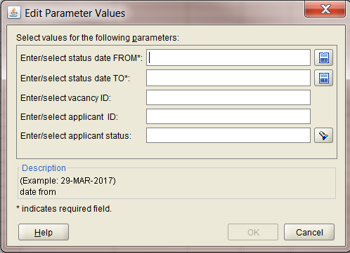

 | NB: the clear down process does not include the date entered in the End Date field in the clear down applicants screen. However when running the Discoverer report the date entered in the Status date TO: field is included.

  - Export the entire workbook into the folder you have created.

  - Pivot the data from the Applicant Detail per Vacancy tab as follows:

Rows:
Applicant status
Applicant status description

Data:
Count of Applicant status

If required edit the pivot table to remove the sub totals.

  - In column D add a sum to show the number of pages that will be returned in the preview report. (Total by status/38)

Clearing down by applicant status

Before you begin you must discuss and agree timescales with the Head of HRIS.

Navigate to Recruitment>Recruitment Maintenance>Applicant Clear Down

The ‘Clear Down Applicants’ window opens:

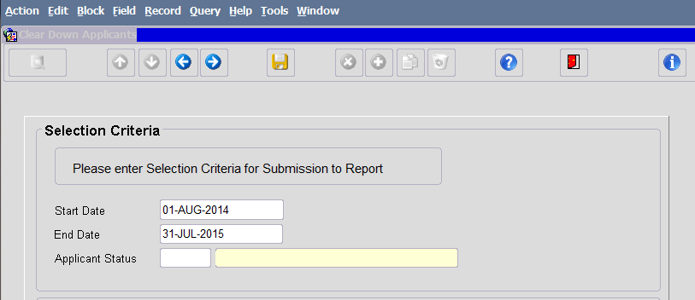

  - Enter date range

Start date = 1 Aug 20xx
End date = 1 Aug 20xx

 | NB: The clear down process does not include the date entered in the End Date field. Therefore to include applicants with a status date of 31 July in a particular year you need to enter 1 Aug for that year in the End Date field.

 | NB: Once a date range has been entered it will remain on the screen until you red door back to the main menu.

  - Enter applicant status (code) in the Applicant Status field or select from the LoV, ensuring your cursor is in the Applicant Status field.

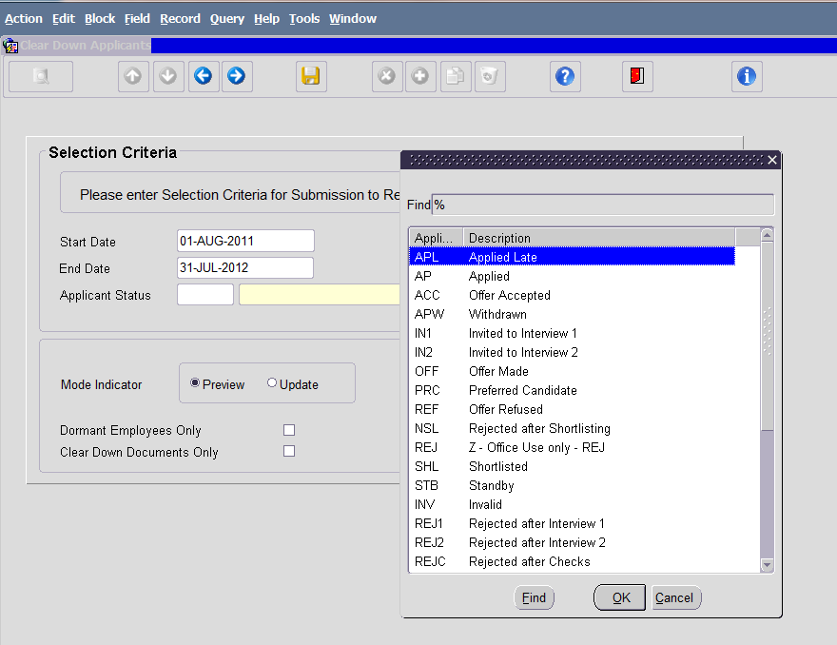

  - To preview the list of applicants that meet the selection criteria, ensure the Mode Indicator is set to ‘Preview’ and click on .

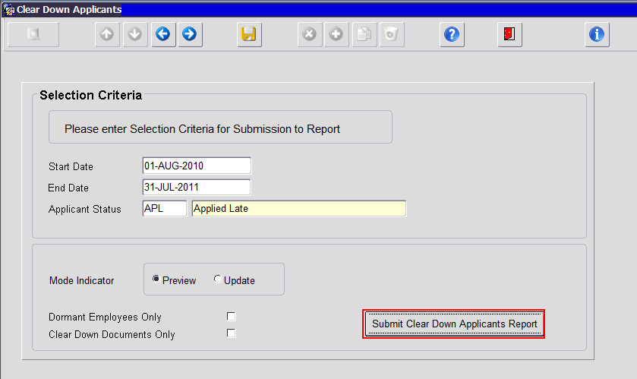

The preview report will open in a new window (sorted in first name order):

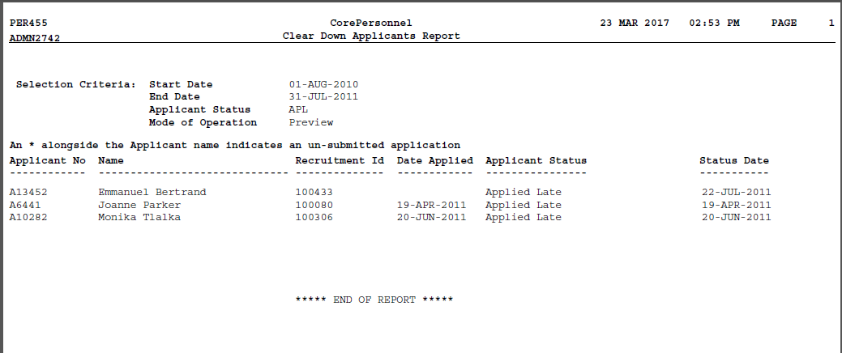

 | NB: there is no applicant count or total on this report so if there are multiple pages there is no easy way of checking the number matches the report. Refer to the pivot table you created to see the approx. number of pages

  - To close the preview report, close the viewing tab/window.

  - To clear down applicants that meet your selection criteria, change the Mode Indicator to ‘Update’ and click on  again. A warning message will appear:

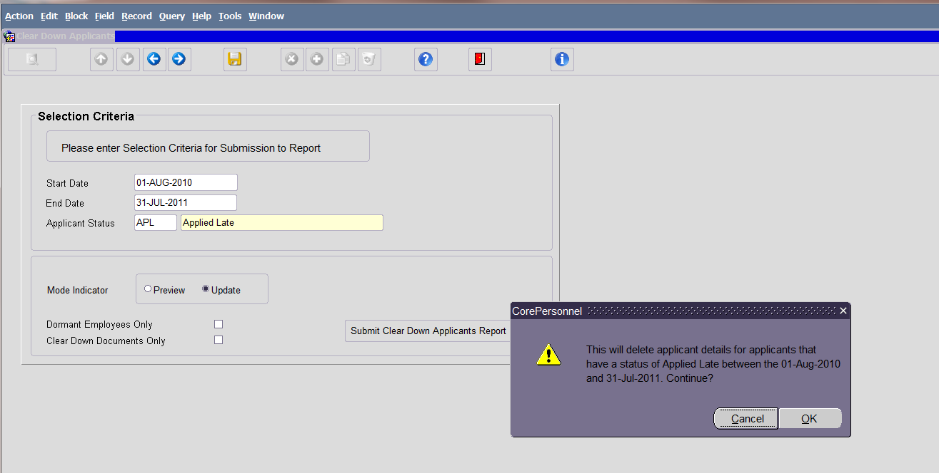

  - Click OK.

A new report will open in a new window (sorted in first name order) confirming the records that have been cleared down:

 | NB: If there are no applicants for your chosen status, a blank report will open.

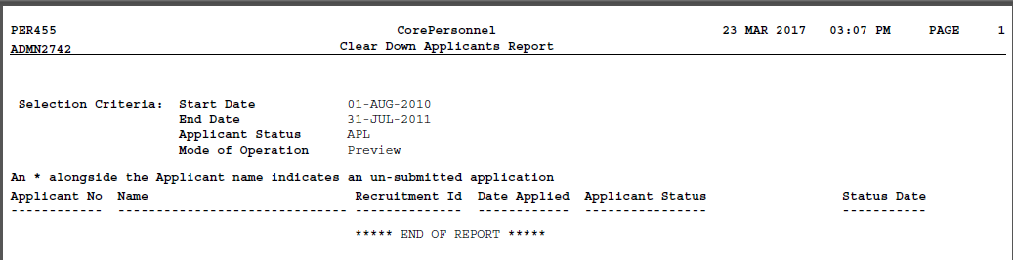

  - Repeat steps 3.3 to 3.6 for each applicant status.

Post clear down checks

Once the clear down process is completed you should carry out a few simple checks.

  - Re-run Discoverer report ‘Bulk applicant clear down control’ for date range and check that nothing is returned.

 | NB: If anything is returned in the report, export it to the folder for the year being cleared and investigate further.

  - View a sample of applicants (Approx. 10) from the Applicant Detail per Vacancy tab in the exported report.

  - Review 1% of vacancies from the Applicant summary by vacancy tab in the exported report where the value in the ‘difference’ column is 0. Check that there are no applicants remaining on the vacancy.

  - Review 1% of vacancies from the Applicant summary by vacancy tab in the exported report where the value in the ‘difference’ column is greater than 0. Check that the number of applicants remaining matches the number of applicants in the difference column.

Removing the merged PDF packs

 | NB: This needs to be completed by CoreHR.

  - Copy the list of vacancies (column A) from the Applicant summary by vacancy tab in the original report and paste into a blank worksheet. Save the new file in the folder you created with the file name ‘List of vacancies for Core to delete merged pack’. (NB: All vacancies should be included even if some applicants remain.)

  - Raise a case with CoreHR and attach the list of vacancies to the case.

  - Enter the case number and date submitted on the checklist.

  - Once CoreHR confirm that they have deleted all of the merged PDF packs, note the date on the checklist.

